South China University of Technology
《Operation System》Experiment Report
Experiment Title： Session 1
Name： 陈宇勋 Student ID： 202230430026
Class： 22计科全英创新班 Group： None
Collaborator： None
Teacher： 钟竞辉
Description
【Objective and Requirement】
Objective：
Be familiar with the creation of process and thread
Requirement：
Task 1: Create a console application, “child”, which keeps printing out “The child is talking at [system time]” (in a loop, one per 1s).
Task 2: Create another console application, “parent”. It create a child process to execute “child”. At the same time, the “parent” process keeps printing out “The parent is talking at [system time]”. (one per 1s). Execute “parent” and explain the output you see.
Task 3: Create a child thread in the “mainThread” program. Both the main thread and the child thread keep printing out “[ThreadID] + [System time]”.
Task 4: Create a console application, which contains a shared integer shared_var. The initial value of shared_var is 0. The application will create a child thread after it starts. The main thread keeps increasing the value of shared_var by 1, while the child thread keeps decreasing the value of shared_var by 1. Explain the observed results.
【Environment】
Operating System：Linux;
Content
【Procedure】
1. Step：For each task, I create a python file to satisfy the requirement. In these python files, I use modules “threading” and “time” to simulate multi-threaded processes. Then I run each file in Ubuntu24.04, and obtain the following results.
2. Results：
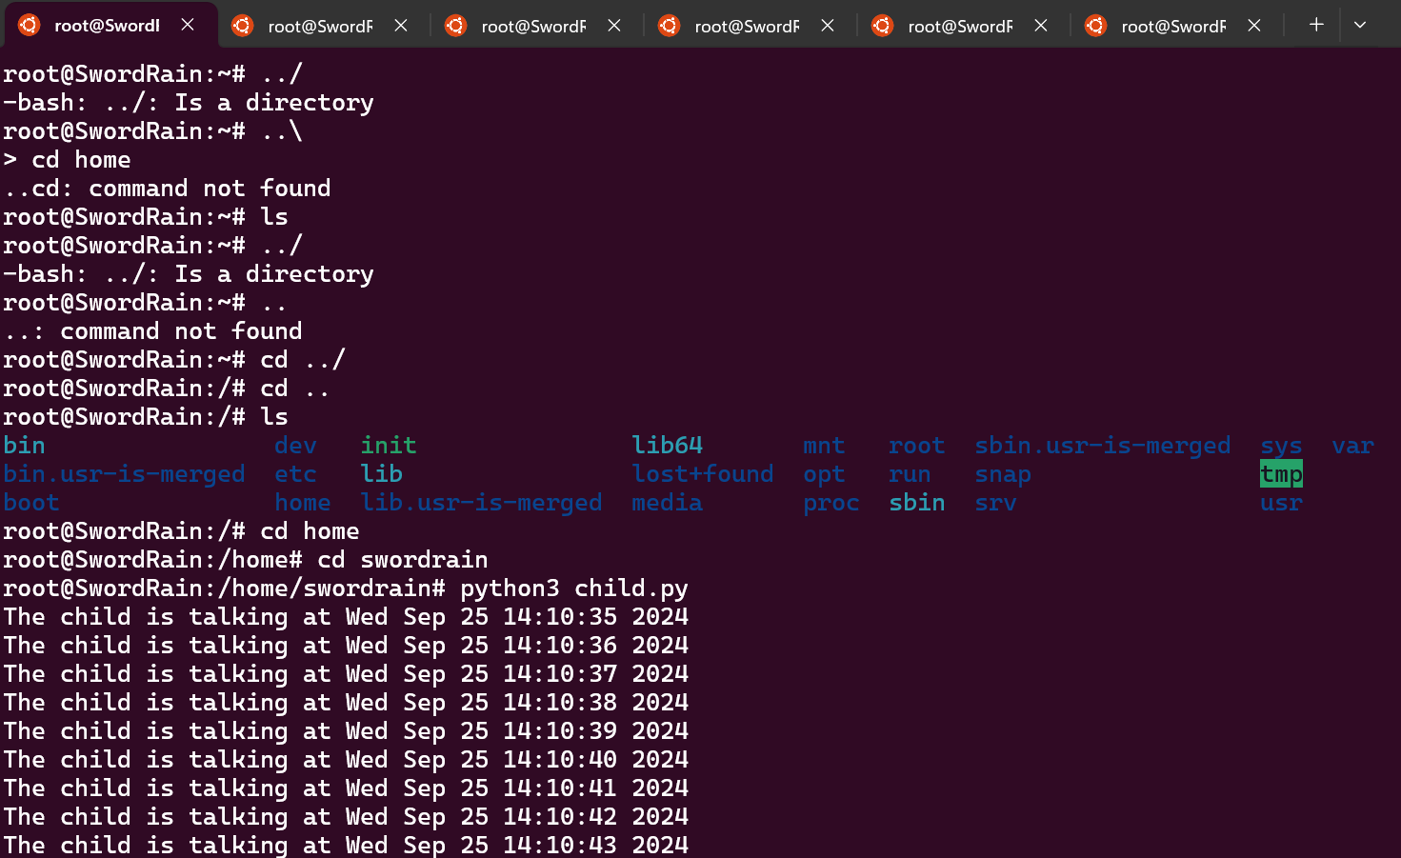
Task 1: the running result of child.py
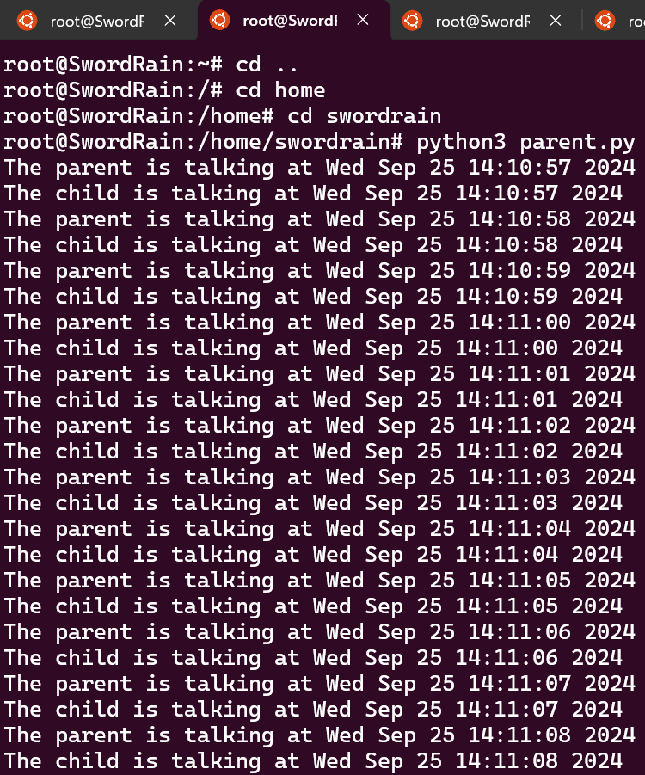
Task 2: the running result of parent.py
In task 2, when the threading “parent” is running, it create a child process named “child”, then they print their text and time together.
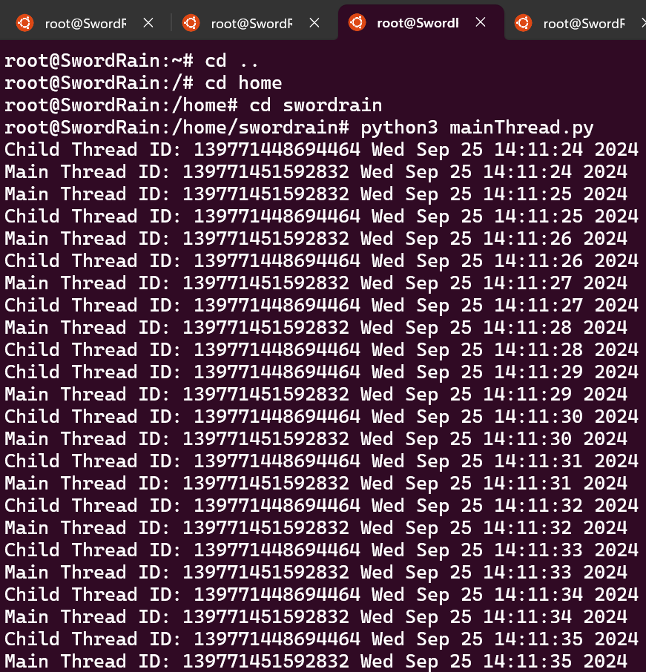
Task 3: the running result of mainThread.py
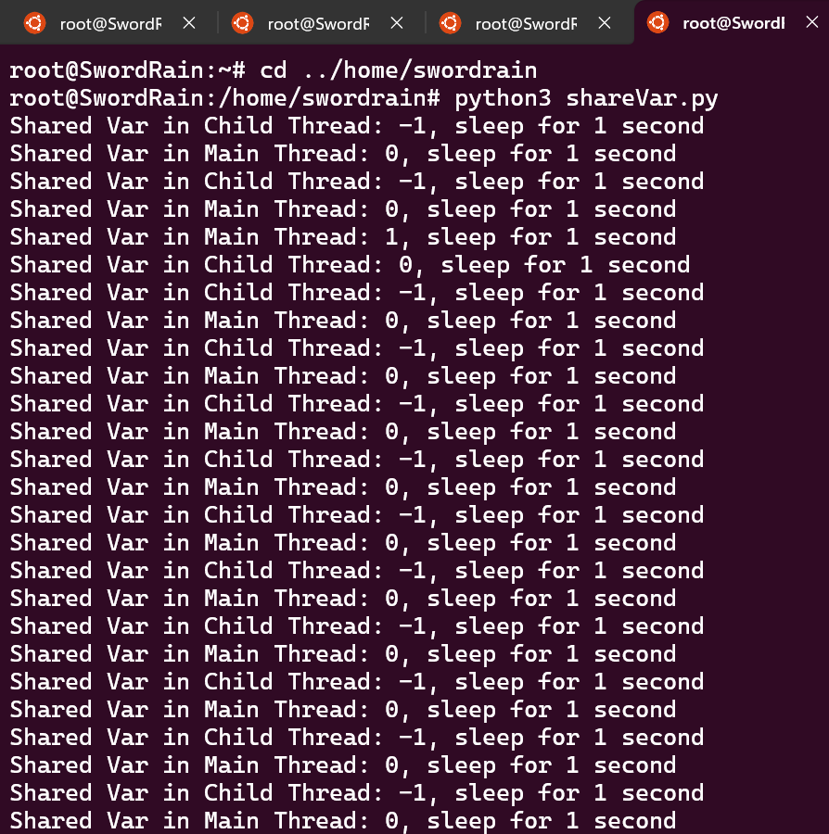
Task 4: the running result of shareVar.py
In task 4, the result is 0 in Main Thread, and 1 in Child Thread. The reason for this result is that these two thread have the same code expect the print content, therefore their running frequency and speed are the same, leading this result.
Conclusion
In this experiment, I have learned about multi-process, which is an important part in Operation System.
Teacher’s Comments and Score
Comment：

Score： Signature：
Date：
Appendix: Python Code for each task
Task 1: child.py
import time

while True:
print(f"The child is talking at {time.ctime()}")
time.sleep(1)
Task 2: parent.py
import time
import os
import subprocess
def parent_process():
while True:
print(f"The parent is talking at {time.ctime()}")
time.sleep(1)

if __name__ == "__main__":
child_process = subprocess.Popen(["python3", "child.py"])
parent_process()
Task 3: mainThread.py
import time
import threading

def child_thread():
while True:
print(f"Child Thread ID: {threading.get_ident()} {time.ctime()}")
time.sleep(1)

def main_thread():
while True:
print(f"Main Thread ID: {threading.get_ident()} {time.ctime()}")
time.sleep(1)

if __name__ == "__main__":
child = threading.Thread(target=child_thread)
child.start()
main_thread()
Task 4: shareVar.py
import time
import threading

shared_var = 0
lock = threading.Lock()

def child_thread():
global shared_var
while True:
with lock:
shared_var -= 1
print(f"Shared Var in Child Thread: {shared_var}, sleep for 1 second")
time.sleep(1)

def main_thread():
global shared_var
while True:
with lock:
shared_var += 1
print(f"Shared Var in Main Thread: {shared_var}, sleep for 1 second")
time.sleep(1)

if __name__ == "__main__":
child = threading.Thread(target=child_thread)
child.start()
main_thread()

